**BWT Task-09 Exercise**

**Submitted By: Abduhu Khan**

**PySpark:**

**Code & Output:**

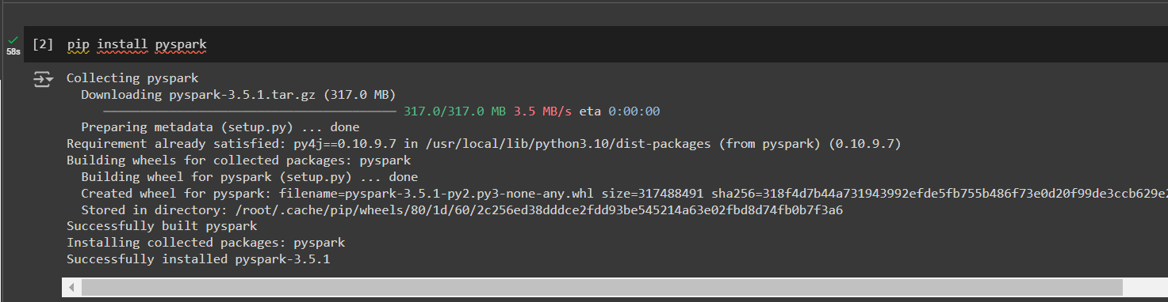

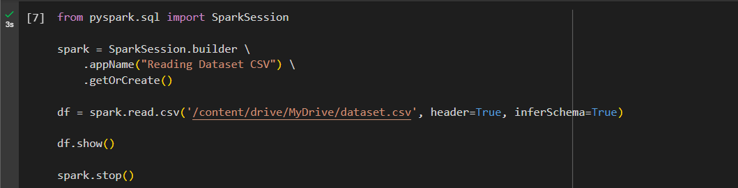

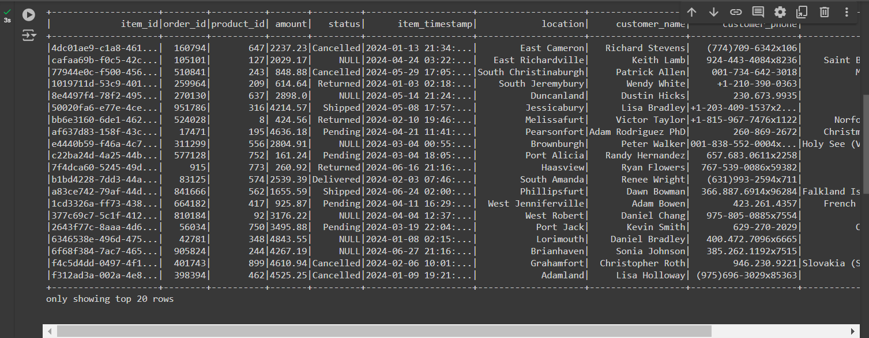

The following code does transformations as mentioned in the previous task for this dataset.csv file which were done using pandas. The same thing can be done using PySpark as follows:

